**BANNARI AMMAN INSTITUTE OF TECHNOLOGY**

SATHYAMANGALAM

Department of

Electronics and Communication Engineering

**A Technical Report**

*submitted as a part of*

**Skill Development Programme**

*on*

Design and Implementation of anObstacle Avoidance Robot

*By*

*Second year students*

*BHARATHRAJ -171EC129 DHARANIDHARAN-171EC144*

*BHARANI ASWATH-171EC126 DEEPAK-171EC139*

*DARSHAN-171EC137 ASHWIN-171EC122*

*SHWETHA-171EC281 AMAR-171EC114*

*VISHNUPRIYA-171EC315 DEEPA-171EC138*

*DEEPIKA-171EC140*

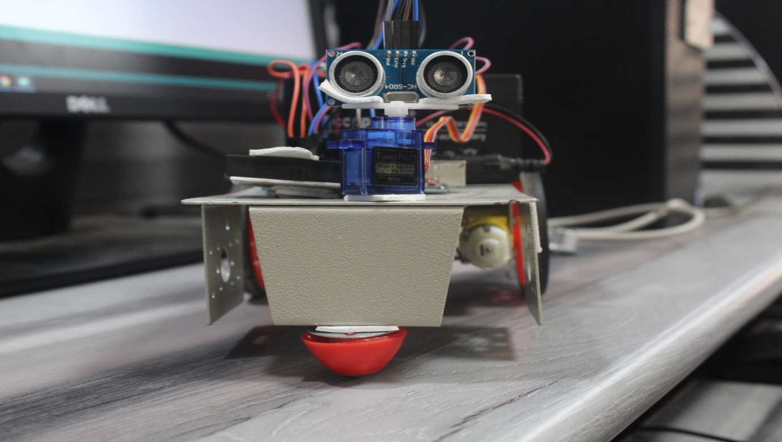

Arduino Based Obstacle Avoidance Robot

**OUTLINE:**

* Abstract
* Introduction
* Methodology
* Implementation
* Conclusion

**ABSTRACT:**

Obstacle avoidance is the important aspect of robotic vehicle. In the absence of obstacle avoidance, the robot movement will be difficult. Obstacle avoidance refers to the ability of a robot to detect obstacle in its way and thus make its own obstacle free path. This project proposes robotic vehicle as intelligence build in it. So it directs itself when an obstacle is detected. This prevents the robot from physical damages. This robot was designed with ultrasonic sensor and servo motor. The desired operation is achieved by microcontroller (AT MEGA 328P).Depending on the input signal received, the microcontroller gives order to the robot to move in an alternate direction. The motors are activated by the motor driver. This can be used in situations like war fields, disasters where human intervention is difficult.

**1. INTRODUCTION**

The applications of robotics are increasing with the advancement of technologies.The concept of moving robots is fast evolving and developing.This device automatically sense and overcome Obstacle in its path.The main objective is the movement of robots on the basis of input got from sensorial information.Path planning is an alternative method when the scenario is not clear.The sensor detects changes consequently for efficient moving.This autonomous moving robot avoids collision with unexpected obstacles.This uses ultrasonic range finder sensor to avoid collision.

**2. METHODOLOGY**

**2.1 CIRCUIT DIAGRAM**

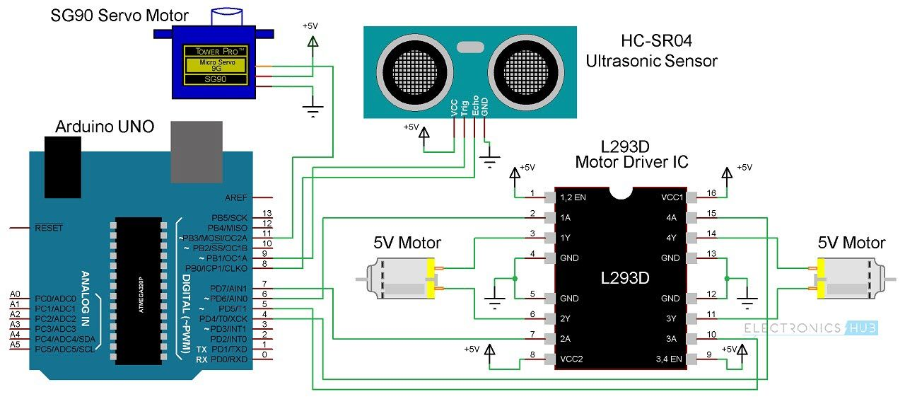

**Fig 1.Circuit connection**

**2.2 COMPONENTS USED**

1.Arduino UNO

2.Ultrasonic range finder sensor

3.Motor driver

4.Servo motor

5.DC motors

6. Power supply

7. Bread board

8. Robot chassis

**2.3 COMPONENTS DESCRIPTION:**

**2.3.1Arduino UNO**

Arduino is an open source electronic platform based on AT MEGA 328P . The hardware and software is easy to use. Arduino boards are able to read inputs like light on a sensor ,a finger on a button and turn it into an output like activating a motor, turning on a led .

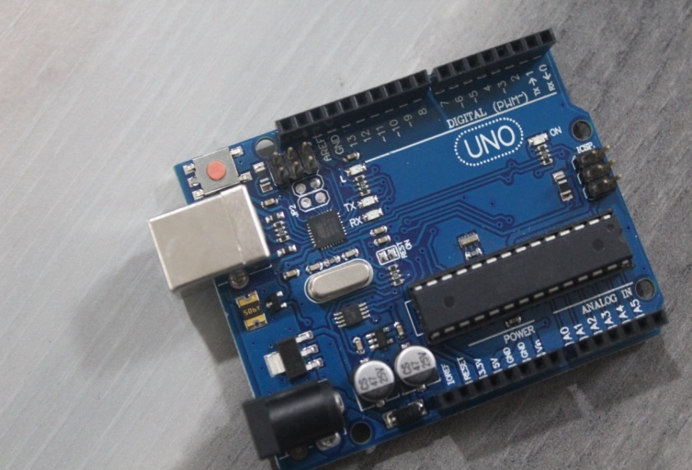

**Fig 2. Arduino UNO**

**2.3.2Ultrasonic sensor**

The ultrasonic waves emitted by the transducer are reflected by an object and received back in the transmission.It uses electrical and mechanical energy transformations to measure the distance.

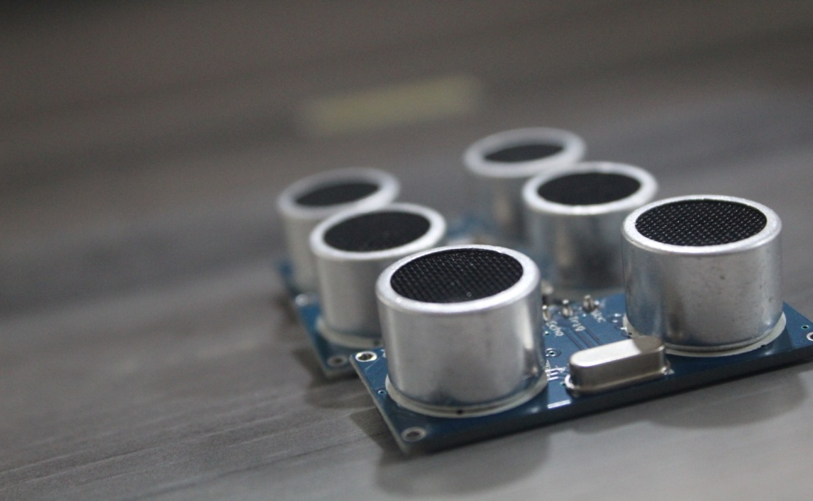

**Fig 3.Ultrasonic sensor**

**2.3.3 Motor driver**

Motor driver IC allows DC motor to drive on bothdirections.It is a 16pin IC which can control 2 DC motors simultaneously in all two directions.

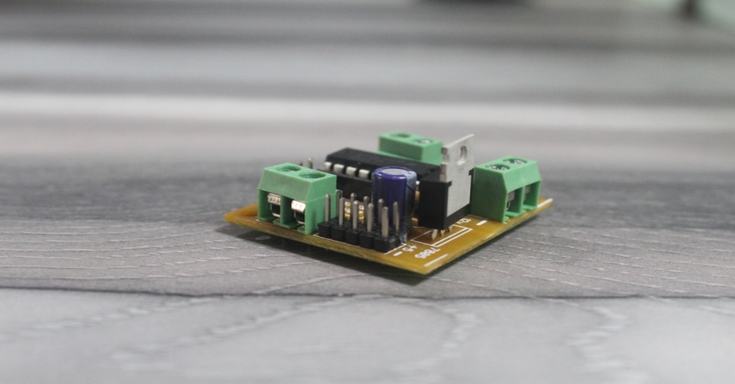

**Fig 4.Motor driver**

**2.3.4 Motors**

DC motor converts electrical to mechanical energy. It helps in rotation of wheels in robot.

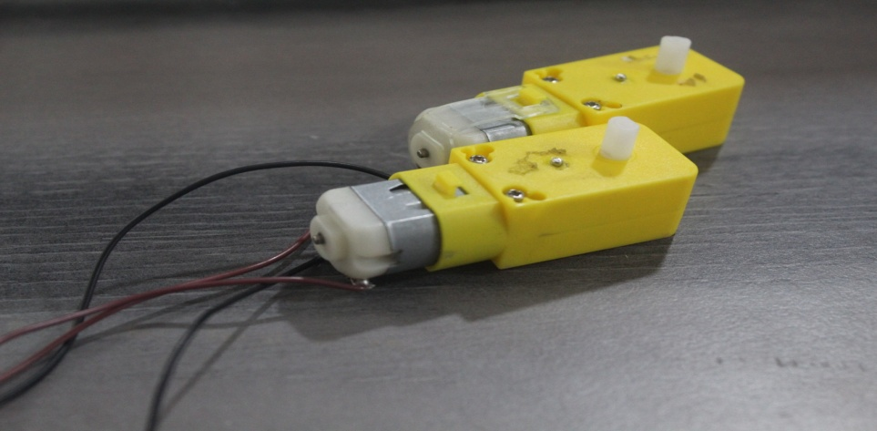

**Fig 5.Motors**

**2.3.5 Servo motor**

It is an electrical device which can rotate an object at some specific angle or distance .This information is processed by the Arduino. If the distance between the robot and the obstacle is less than 30cm, the Robot stops and scans in left and right directions for new distance using Servo Motor and Ultrasonic Sensor. If the distance towards the left side is more than that of the right side, the robot will prepare for a left turn.

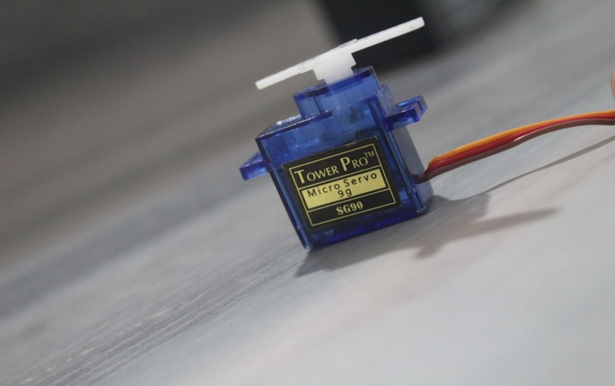

**Fig 6.Servo motor**

**2.4 BLOCK DIAGRAM**

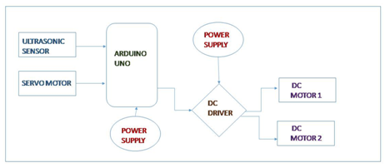

**Fig 6.Block diagram**

**3. IMPLEMENTATION:**

The implementation of obstacle avoidance for the robot involves writing a program using Arduino software (Arduino IDE). Arduino is a popular programmable board to create projects. It has a simple hardware platform on which microcontroller is placed and a code editor which has one click compile or upload feature. Thus it is designed for people who are not expert in programming. Arduino is easy to use and flexible for people who are beginners in robotics with both hardware and software perspective.In this method the implementation is done.

**4. WORKING**

The ability to operate independently is based on the [ultrasonic sensor](https://www.allaboutcircuits.com/electronic-components/datasheet/SEN-13959-Spark-Fun) placed on the robot. The ultrasonic sensor sends a high-frequency sound waves and waits for those sound waves to reflect back from the object and calculates how long it takes to return to the sensor. The sensorhas send &receive pins named "trigger" and "echo" respectively. The signals return back after reflecting from a surface and the receiver sensesthe signal. The Echo pin is high from the time of sending the signal and receiving it back. This time interval can be converted to distance using calculations.

Ourgoal is to make an obstacle avoiding robot using ultrasonic sensor and Arduino. The connections are made according to the circuit connections. The working of the project is explained here. When the robot is turned on both the motors of the robot will run normally and the robot moves forward. On the meanwhile, the ultrasonic sensor continuously calculate the distance between the robot and obstacle. This information is processed by the Arduino. If the distance between the robot and the obstacle is less than 30cm, the driver stops the motor and scans in left and right direction using servo motor and ultrasonic sensor. If the distance towards the left side is more than that of the right side, the robot will turnleft. If the right distance is more than that of the left distance, the robot will turn right.  This process continues forever and the robot keeps on moving without hitting any obstacle. This process is repeated throughout the movement of vehicle.

**5. CONCLUSION**

This robot was designed and implemented with (AT MEGA 328P) microcontroller. This project has manipulated the different parts of the robot to make it react accordingly. Sensors input will be sent to the controller .According to the program fed in the controller, the robot is instructed to do the work.

**REFERENCES:**

1. [https://www.electronicshub.org/obstacle-avoiding-robot-arduino](https://www.electronicshub.org/obstacle-avoiding-robot-arduino/)
2. [https://www.elprocus.com/obstacle-avoidance-robotic-vehicle](https://www.elprocus.com/obstacle-avoidance-robotic-vehicle/)